25.14.7 Editors - Properties Editor - Physics - Smoke
Smoke Simulation 1
Workflow 1
Technical information 2
Smoke Domain 2
Settings 3
Smoke Flames 5
Smoke Adaptive Domain 5
Smoke High Resolution 5
Smoke Groups 7
Smoke Cache 7
Smoke Field Weights 7
Note on Divisions and High Resolution 8
Smoke Flow Object 9
Settings 10
Flow Type 10
Flow Source 10
Initial Values 11
Smoke Flow Advanced 13
Collisions 14
Forces 15
Smoke Material 15
Baking Smoke Simulations 15

Smoke Simulation

Smoke simulation is used to simulate the fluid movement of air and generate animated voxel textures representing the density, heat, and velocity of other fluids or suspended particles (i.e. smoke) which can be used for rendering.
Smoke and fire are emitted into a Domain from a mesh object or particle system. Smoke movement is controlled by airflow inside the domain, which can be influenced by smoke collision objects. Smoke will also be affected by scene gravity and force fields. Airflow inside the domain can affect other physics simulations via the smoke flow force field.

Workflow
At least a Domain Object object and one Flow object are required to create a smoke simulation. A basic workflow looks like this:
- Create a Domain Object that defines the bounds of the simulation volume.
- Define a Flow object or objects which will emit smoke and fire.
- Set Collision objects to make the smoke interact with objects in the scene.
- Assign a Volumetric material to the domain object.
- Save the .blend.
- Bake the simulation.
Note
There is a Quick Smoke operator which will automatically create a domain object with a basic smoke/fire material. It can be found in 3D View ‣ Object ‣ Quick Effects ‣ Quick Smoke, or in the Spacebar search box.

Technical information
Bforartists’s smoke simulation is based on the paper Wavelet Turbulence for Fluid Simulation and associated sample code.
It has been implemented in Bforartists by Daniel Genrich and Miika Hamalainen.

Smoke Domain
The domain object contains the entire simulation. Smoke and fire cannot leave the domain, it will either collide with the edge or disappear, depending on the domain’s settings.
Keep in mind that large domains require higher resolutions and longer bake times. You’ll want to make it just large enough that the simulation will fit inside it, but not so large that it takes too long to compute the simulation.
To create a domain, add a cube and transform it until it encloses the area where you want smoke. Translation, rotation, and scaling are all allowed. To turn it into a smoke domain, click Smoke in Properties ‣ Physics, then select Domain as the Smoke Type.
Note
You can use other shapes of mesh objects as domain objects, but the smoke simulator will use the shape’s bounding box as the domain bounds. In other words, the actual shape of the domain will still be rectangular.

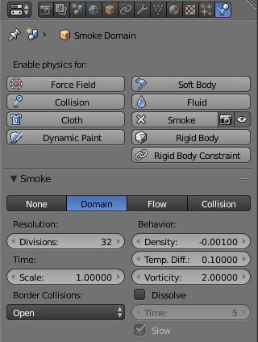
Smoke Domain settings.

Settings
Resolution
The smoke domain is subdivided into many “cells” called voxels (see voxel) which make up “pixels” of smoke. This setting controls the number of subdivisions in the domain. Higher numbers of subdivisions are one way of creating higher resolution smoke (See Smoke High Resolution)
Since the resolution is defined in terms of subdivisions, larger domains will need more divisions to get an equivalent resolution to a small domain.
Also see Note on Divisions and High Resolution.
Time Scale
Controls the speed of the simulation. Low values result in a “slow motion” simulation, while higher values can be used to advance the simulation faster (useful for generating smoke for use in still renders).
Border Collisions
Controls which sides of the domain will allow smoke “through” the domain, making it disappear without influencing the rest of the simulation, and which sides will deflect smoke as if colliding with a Collision Object.
Vertically Open
Smoke disappears when it hits the top or bottom of the domain, but collides with the walls.
Open
Smoke disappears when it hits any side of the domain.
Collide All
Smoke collides with all sides of the domain.
Density
Controls how much smoke is affected by density.
- Values above 0 will cause the smoke to rise (simulating smoke which is lighter than ambient air).
- Values below 0 will cause smoke to sink (simulating smoke which is heavier than ambient air).
Temp. Diff.
The Temperature Difference setting controls how much smoke is affected by temperature.
The effect this setting has on smoke depends on the per flow object *Temp. Diff.* setting:
- Values above 0 will result in the smoke rising when the flow object Temp. Diff. is set to a positive value, and smoke sinking when the flow object Temp. Diff. is set to a negative value.
- Values below 0 will result in the opposite of positive values, i.e. smoke emitted from flow objects with a positive Temp. Diff. will sink, and smoke from flow objects with a negative Temp. Diff. will rise.
Note that smoke from multiple flow objects with different temperatures will mix and warm up/cool down until an equilibrium is reached.
Vorticity
Controls the amount of turbulence in the smoke. Higher values will make lots of small swirls, while lower values make smoother shapes.
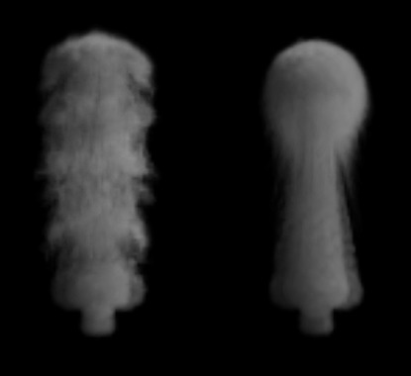
Comparison of different amounts of vorticity. The domain on the left has a vorticity of 3, while the domain on the right has a vorticity of .01.
Dissolve
Allow smoke to dissipate over time.
Time
Speed of smoke’s dissipation in frames.
Slow
Dissolve smoke in a logarithmic fashion. Dissolves quickly at first, but lingers longer.

Smoke Flames
Speed
How fast fuel burns. Larger values result in smaller flames (fuel burns before it can go very far), smaller values result in larger flames (fuel has time to flow farther before being fully consumed).
Smoke
Amount of extra smoke created automatically to simulate burnt fuel.
Vorticity
Additional vorticity for flames.
Ignition
Minimum temperature of flames.
Maximum
Maximum temperature of flames.
Smoke Color
Color of smoke created by burnt fuel.

Smoke Adaptive Domain
When enabled, the domain will adaptively shrink to best fit the smoke, saving computation time by leaving voxels without smoke out of the simulation. Unless the Additional option is used, the adaptive domain will not exceed the bounds of the original domain.
Additional
Number of voxels to add around the outside of the domain.
Margin
Amount of extra space to leave around smoke, measured in voxels. With very fast moving smoke larger margins may be required to prevent the smoke from being cut off by the adaptive boundary, but note this will increase the number of voxels which need to be computed.
Threshold
Smallest amount of smoke a voxel can contain before it’s considered empty and the adaptive domain is allowed to cut it out of the simulation.

Smoke High Resolution
The High Resolution option lets you simulate at low resolution and then uses noise techniques to enhance the resolution without actually computing it. This allows animators to set up a low resolution simulation quickly and later add details without changing the overall fluid motion. Also see Note on Divisions and High Resolution.
Resolution/Divisions
Factor by which to enhance the resolution of smoke using the specified noise method.
Show High Resolution
Show high resolution in the viewport (may cause viewport responsiveness to suffer).
Noise Method
The two options, Wavelet and FFT, are very similar.
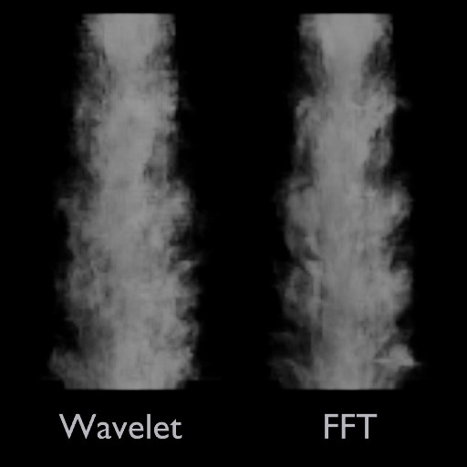
Comparison of noise methods. Wavelet on the left, FFT on the right.

Note
Wavelet is an implementation of Turbulence for Fluid Simulation.

Strength
Strength of noise.
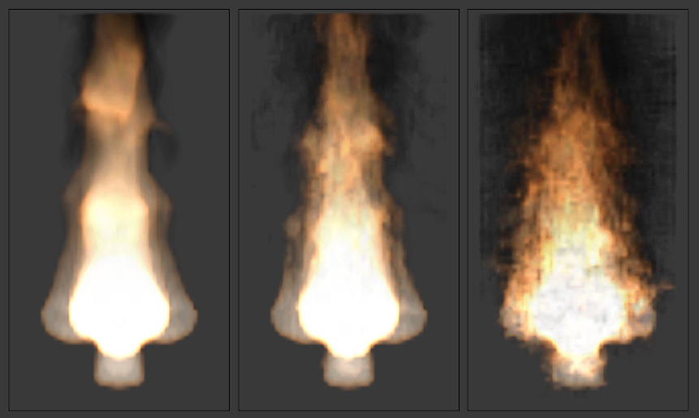
From left to right, the domains’ high resolution strengths are set to 0, 2, and 6.

Smoke Groups
Flow Group
If set, only objects in the specified Group will be allowed to act as flow objects in this domain.
Collision Group
If set, only objects in the specified Group will be allowed to act as collision objects in this domain.

Smoke Cache
See Baking.

Smoke Field Weights
These settings determine how much gravity and Force Fields affect the smoke.
Effector Group
When set, smoke can only be influenced by force fields in the specified group.
Gravity
How much the smoke is affected by Gravity.
All
Overall influence of all force fields.
The other settings determine how much influence individual force field types have.
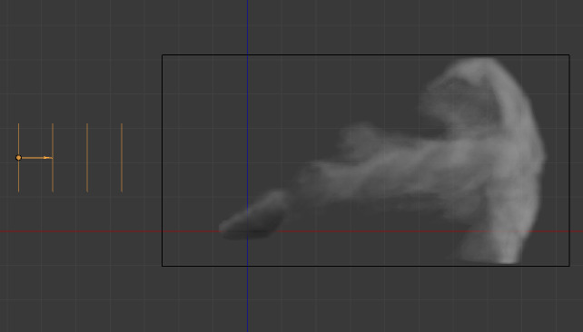
Smoke with a wind force field.

Note on Divisions and High Resolution
High Resolution Divisions and Domain Subdivisions are not equivalent. By using different combinations of these resolution settings you can obtain a variety of different styles of smoke.
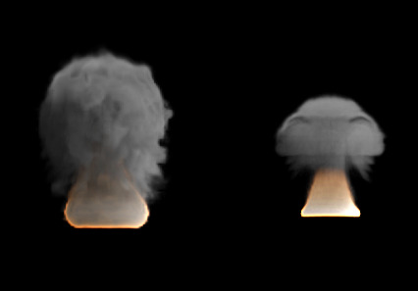
Comparison between a domain with 24 divisions and 4 High Resolution divisions (left), and a domain with 100 divisions and 1 High Resolution division (right).
Low division simulations with lots of High Resolution divisions generally appear smaller in real-world scale (larger flames etc.) and can be used to achieve pyroclastic plumes such as this:
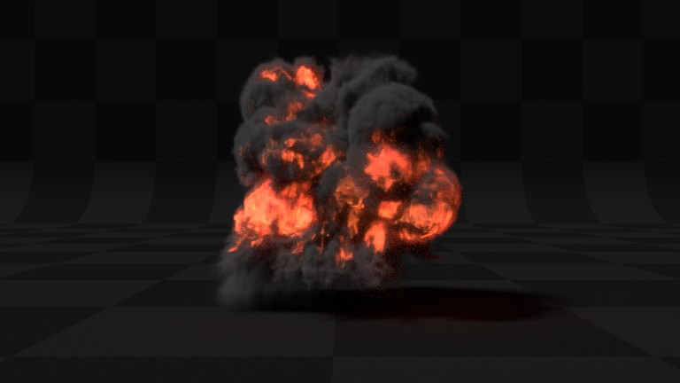
High Domain Division simulations tend to appear larger in real-world scale, with many smaller details.

Smoke Flow Object

Smoke Flow objects are used to add or remove smoke and fire to a Smoke Domain object.
To define any mesh object as a Smoke Flow object, add smoke physics by clicking Smoke in Properties ‣ Physics. Then select Flow as the Smoke Type. Now you should have a default smoke flow source object. You can test this by playing the animation from the first frame. If your source object is inside your domain, you should see smoke.

Settings
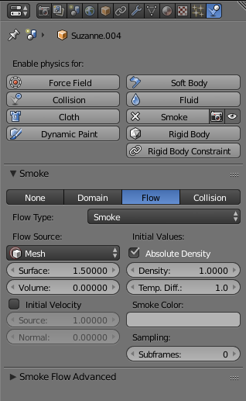
Smoke Flow settings

Flow Type
Fire
Emit only fire. Note that the domain will automatically create some smoke to simulate smoke left by burnt fuel.
Smoke
Emit only smoke.
Fire + Smoke
Emit both fire and smoke.
Outflow
Remove smoke and fire. Note that the shape of the outflow will use the object’s bounding box.

Flow Source
Source
This setting defines the method used to emit smoke and fire.
Mesh
Create smoke/fire directly from the object’s mesh. With this option selected there two additional settings, Surface and Volume.
Surface
Maximum distance in voxels from the surface of the mesh in which smoke is created (see voxel). Since this setting uses voxels to determine distance, results will vary depending on the domain’s resolution.
Volume
Amount of smoke to emit inside the emitter mesh, where 0 is none and 1 is Note that emitting smoke based on volume may have unpredictable results if your mesh is non-manifold.
Particle System
Create smoke/fire from a particle system on the flow object. Note that only Emitter type particle systems can add smoke. See Particles for information on how to create a particle system.
With this option selected there is a box to select a particle system and one addition setting, Set Size.
Set Size
When this setting is enabled it allows the Size setting to define the maximum distance in voxels at which particles can emit smoke, similar to the *Surface* setting for mesh sources.
When disabled, particles will fill the nearest voxel with smoke.
Initial Velocity
When enabled, smoke will inherit the momentum of the flow source.
Source
Multiplier for inherited velocity. A value of 1 will emit smoke moving at the same speed as the source.
Normal
When using a mesh source, this option controls how much velocity smoke is given along the source’s normal.

Initial Values
Smoke Color
Color of emitted smoke. When smoke of different colors are mixed they will blend together, eventually settling into a new combined color.
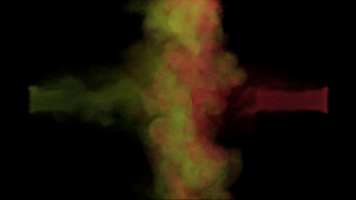
Flame Rate:
Amount of “fuel” being burned per second. Larger values result in larger flames, smaller values result in smaller flames:
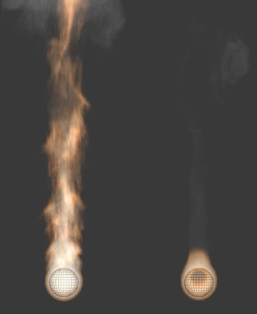
Example showing two fire sources. The object on the left has a Flame Rate of 5, while the one on the right has 0.3.
Absolute Density
Maximum density of smoke allowed within range of the source.
Density
Amount of smoke to emit at once.
Temp. Diff.
Difference between the temperature of emitted smoke and the domain’s ambient temperature. This setting’s effect on smoke depends on the domain’s *Temp. Diff.* setting.
Sampling
Number of sub-frames used to reduce gaps in emission of smoke from fast-moving sources.
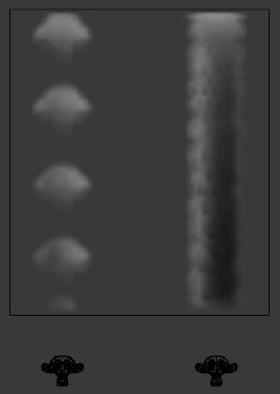
Example showing two fast moving sources. The object on the left uses 0 subframes, while the one on the right uses 6.

Smoke Flow Advanced
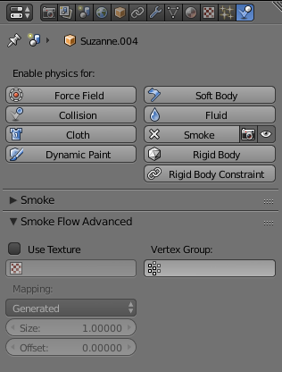
When using a mesh as the Flow Source, you can use these settings to control where on the mesh smoke can be emitted from. These settings have no effect on outflow objects.
Use Texture
When enabled, use the specified texture to control where smoke is emitted.
Vertex Group
When set, use the specified Vertex Group to control where smoke is emitted.
These settings are useful for effects like this:
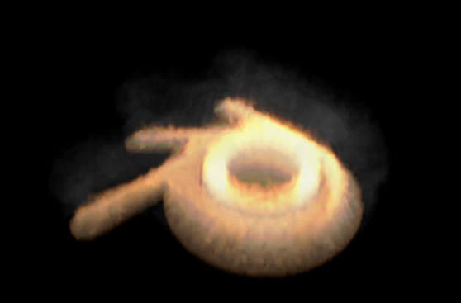

Collisions

Smoke Collision objects are used to deflect smoke and influence airflow.
To define any mesh object as a Smoke Collision object, add smoke physics by clicking Smoke in Properties ‣ Physics. Then select Collision as the Smoke Type.
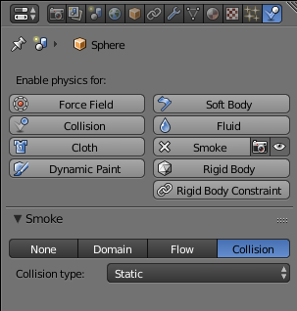
Smoke Collision settings
Collision type
Static
Simple collision model which can be calculated quickly, but may be inaccurate for moving objects.
Animated
More complex collision model which takes into account impulse imparted to smoke when the collider is moving. Calculations are slower, but more accurate for moving objects.
Rigid
Identical to Static (unfinished code).

Forces
Force Fields (such as wind or vortex) are supported, like most physics systems. The influence individual force types have can be controlled per domain object.

Smoke Material

Bforartists has multiple render engines each with their own method of rendering smoke-data:
- Bforartists Internal
- Cycles Render

Baking Smoke Simulations

Baking is used to store the outcome of a simulation so it doesn’t need to be recalculated.
Smoke baking settings are in Properties ‣ Physics ‣ Smoke ‣ Smoke Cache. See Baking Physics Simulations.
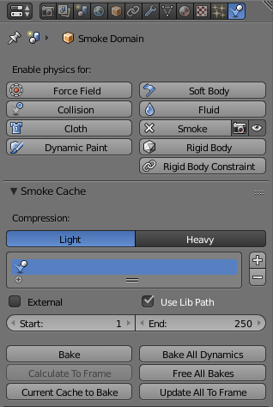
Smoke Cache options
Note
Baking can only been done once your .blend is saved. If your .blend has not been saved, the Smoke Cache panel will be disabled.

